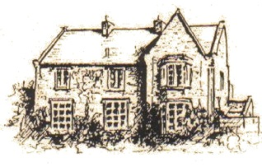
HUGH JOICEY C.E. AIDED FIRST SCHOOL, FORD,
Berwick Upon Tweed TD15 2QA 01890 820217
admin@ford.northumberland.sch.uk
www.ford.northumberland.sch.uk
Headteacher: Mrs Jacqueline Dalrymple M.Ed

Happy, Healthy, Aspirational Learners in a Christian Community

June 2018

Dear Parents and Families,

The last half term is rattling along and we’d just like to draw your attention to some new dates, including an opportunity for all parents and carers to come in to school to have a look around and to look through your children’s books together with your child. We think the children would love to show off their hard work and we hope it will give you a greater insight into how we learn at Ford First School.

Open Morning: We will be open to visitors from 9-12am on Tuesday 17th July if you can drop in for half an hour it would be great to see you. The children can show you around and talk about their work and displays. This is a new activity to welcome parents into school for an additional date so please take advantage of the opportunity if you can and we hope to develop termly open mornings/stay and play next year – if you have further suggestions, do let us know. We anticipate a busy but interesting morning!
Year 4 parents may like to wait until Wednesday when you can stay for tea and cake and a chat with Year 4 leavers and teachers after the Leavers’ Assembly. If you have a Y4 leaver and a younger child you could see their books on the Wednesday too.

New playground: We are delighted with our new play equipment and the children are giving it a thorough testing this week. We have drawn up a timetable to ensure every year group gets a fair turn. The children are already challenging themselves on the monkey bars – great for gross motor skills- we have some extremely agile children! We’ve also used the equipment in English lessons for prepositional and story language and Maths for measuring angles.
Safety: We are supervising closely and ensuring the children follow the rules to stay safe during all playtimes. If your children do have a few minutes on the equipment at home time on your way out it is your responsibility to keep them safe, thank you for your cooperation in this matter.

Sally’s Spring Walk: over £1300! THANK YOU! We had a fabulous turnout for Sally’s Spring walk. It was a beautiful day and we were delighted to welcome all of Sally’s family, including new additions. You helped raise a tremendous amount of money, over £1300, and the collection tin is still to be counted. Special thanks to Madyson and Jenson for raising over an extraordinary £500, and very generous contributions from Willow and Reuel, Olivia, Rowan, Flora, Katie M, Jacob, Isaac, El-T’Chei, Channah and Ebony, Emmie and Katie, Maisie, Alfie and Sophia and many others into the collecting tin on the day. However large or small the contribution though, every penny is appreciated by Hospice Care and used to support families like the Woods. The most important part for us though is to show that Sally is very much always in our thoughts and we work every day to carry on her good work and to develop the happy, vibrant ethos she envisioned for our school.

Lady Waterford bicentenary –Watchtower Exhibition – A message from Lady Joicey: “I would like, on behalf of the Lady Waterford Hall Trustees, to thank everyone who took part in our bicentenary art competition – the artists, the teachers, the judges, those who helped to spread the word about it, the owner of The Watchtower Gallery, Scott Robertson who took a lot of trouble to hang the work, and I am sure several others who I should mention. The resulting exhibition at The Watchtower is lovely!

The judges enjoyed their task of looking through the work submitted, all very different, and each child will get a certificate to show that they entered the competition. The following were chosen as being worthy of special mention:

Alistair Nuttall, Mary Waugh and El-T’Chei Olah

The artist who takes home the accolade of being picked out as overall winner goes to Hannah MacDonald from Eyemouth school. Well done indeed to her.”

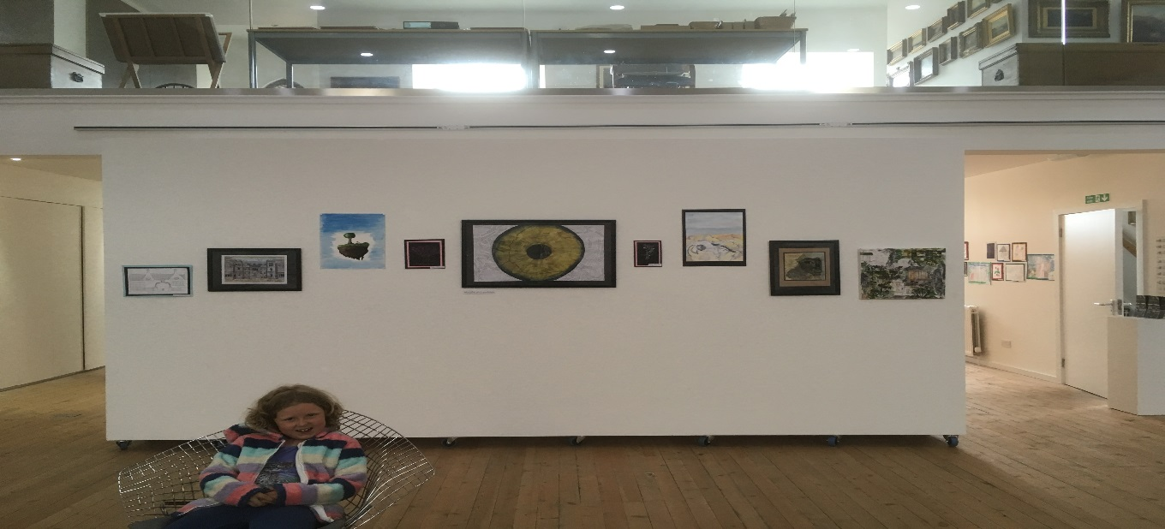

Excellent behaviour: We are especially proud of our children when we take them out of school. Stall holders at Countryside Day complimented our children on their good manners and excellent questions. Staff from other schools noted the collaboration and commitment of our Year 4s to complete challenges, including abseiling and den building. Mrs Rawlings and I were very proud to accompany them and were impressed with how they coped away from home, developing independence and friendships in readiness for Middle School. Well done everyone!

Attendance: Spring term attendance was 97.5% overall but a few individuals have dipped below this – we understand holidays are sometimes difficult/expensive to arrange out of term time, especially for those in farming, but children will be marked as unauthorised absence in all but the most exceptional circumstances as specified by the DfE. If your child will be unavoidably absent please let us know anyway, thank you.

Summer 2 Term arrangements:
- STEM club – Mondays, collect 4.15
- Cricket, coach and club –Fridays collect 4.15
- Sports day club – Mondays 3.15 – 4.15, all Year groups (Year 4 Leaders as helpers)
- Ford’s Got Talent – 19th June, in-school talent show arranged by School Council – get practising!
- Raspberry Pi – 19th June, Coding training for Mrs Green.
- Pre-school transition visits – 20th, 27th June, 4th, 11th July.
- Polar science workshop – Berwick Academy STEM – Y2,3,4 21st June, am.
- School Improvement Partner visit – 21st June, LEA
- Middle school transition – Y4s to Berwick Middle and Glendale – 22nd June
- Full Governors Meeting – Monday 25th June – new Governors observing
- Newcastle Cathedral – Wednesday 27th June Y4 Leavers Service – coach to Newcastle, packed lunch, Discovery Museum, café for treat.
- Oak and Cherry class (R, Y1, Y2) trip to Whitehouse Farm –Tuesday 3rd July
- Beech class trip (Y3,Y4) – Tuesday 3rd July Holy Island Priory as part of Vikings Topic
- New starters parents’ meeting – 4th July 3.15 – Miss Carr and Mrs Dalrymple
- SEN conference – Mrs Dalrymple Friday 6th July
- Y4 Ford Forest afternoon –Tuesday 10th July Partnership transition with Richard Wood
- Reports out –Thursday 12th July
- Glendale Parent Information evening: 6pm Thursday 12th July
- Open Morning – Tuesday 17th July, 9-12, drop in
- Year 4 Leavers Assembly 9.00– Wednesday 18th July - Year 4 families stay for tea and cake.
- Sports day and PTA BBQ afternoon – Friday 20th July, 1.00, on the field – All welcome, final day.
- Break up – Friday 20th July
- Teacher training days : Child Protection, Curriculum development across Partnership
- Back to school – Wednesday 5th September, 8.45

There is copy of this letter on the school website and dates are also on the website calendar.
If you have any questions, queries or concerns please contact us directly as soon as possible. Thank you.
Yours sincerely,
Mrs Dalrymple

