
HUGH JOICEY C.E. AIDED FIRST SCHOOL FORD
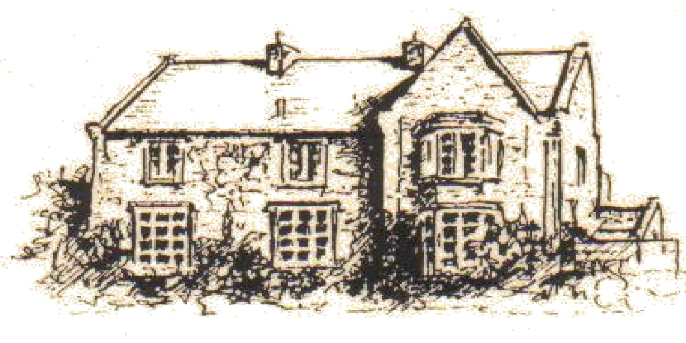

Ford
Berwick Upon Tweed TD15 2QA
Telephone 01890 820217
e-mail: admin@ford.northumberland.sch.uk
website: www.ford.northumberland.sch.uk
Headteacher: Mrs Jacqueline Dalrymple M.Ed

26th January 2017

Dear Parents,

I’d just like to give you a quick update. With our growing class sizes we have decided to adapt how we use our premises and resources to best suit the needs of the children.

CLASS CHANGES:
- Beech class (Key Stage 2, mixed Year 3 and 4) have moved upstairs to the renovated classroom, with additional space to work in the library, kitchen and intervention room when they are doing practical/science/art/research activities. There are also new toilet facilities and a joiner will be fitting cloakroom pegs shortly. It is a lovely space and we are delighted with how sensibly the children are adapting.
- Cherry Class (Key Stage 1, mixed Year 1 and 2) will also be adapting how they work for some of the time until at least half term. Miss Jeffrey and Miss Connelly will teach English and Maths each morning in 2 classrooms and children will be grouped and challenged according to their requirements. If you have any questions please get in touch.

SKIPPING: We’re very proud of Beech class for representing the school so well last week. Ford won the Skip Dance competition and many individual Gold, Silver and Bronze certificates. They practised and performed brilliantly. Thank you to Mrs Turner for coaching and Mrs Green’s choreography.

CHERRY CLASS TRIP:
Please remember Tuesday is Cherry class trip to Centre for Life, please remember packed lunch unless you have arranged with Mrs Morning to provide one. ***LATE PICKUP***

DATES: *****New Dates*** Please check website for updates.
Film club – every Tuesday, 3.15 – 4.15
Rugby club – every Friday afternoon lesson plus club, 3.15-4.15 – warm PE kit and trainers required
Swimming- Oak class, Wednesday afternoon
Forest – Beech –see homework diaries or leave in school please, Cherry – Tuesdays, Oak – Wednesday mornings.
Tuesday 31st January – Cherry Class Space trip to Life Centre, Newcastle
Tuesday 7th February – Theatre group for Internet Safety Workshop (Cyber Adventure) with Cherry Class then Play in A Day (Click Safe) with Beech Class.
Tuesday 7th February – 2.30 Beech class Performance of Click Safe. **ALL WELCOME**
Monday 13th February: - Hoopstarz, all classes

Break up 17th February and back to school on Monday 27th
Beech class swimming from 1st March

Tuesday 28th February – Reception trip to Woodhorn Colliery – Lego Dinosaurs
Wednesday 1st March, 9.30 – Eucharist, Ash Wednesday, ALL WELCOME
Thursday 2nd March – World Book Day
Thursday 2nd March – Year 4 Scremerston, get to know you day.
Monday 6th March – Visit from the Bishop of Berwick
Wednesday 15th March – Parent consultations
Thursday 30th March – Year 4 Forest get to know you day, led by Richard Wood.

LOST PROPERTY: New hoodie 32”, named Moor. Please check at home and ensure all your child’s belongings are named, sometimes names wash out or fall off.

PE kits: We have a new order of red, embroidered Ford PE bags including black shorts and red embroidered Ford T-shirt for only £8! They’re lovely, please ask in the office.

Yours sincerely

Mrs Dalrymple

