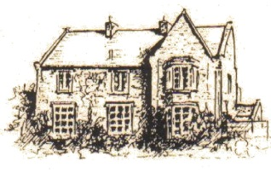
HUGH JOICEY C.E. AIDED FIRST SCHOOL, FORD,
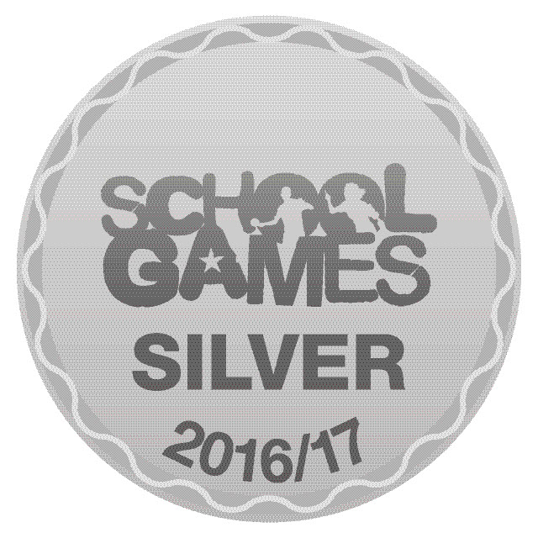
Berwick Upon Tweed TD15 2QA 01890 820217
admin@ford.northumberland.sch.uk
www.ford.northumberland.sch.uk
Headteacher: Mrs Jacqueline Dalrymple M.Ed

Happy, Healthy Learners in a Christian Community

16th November, 2018

Dear Parents and Families,

Children in Need
Thank you for the fantastic support for Children in Need day – you helped to raise a staggering £350. There was a great turnout for the coffee morning and the children thoroughly enjoyed the event – we look forward to doing it again. Thank you for the delicious contributions of baking – you were very generous.

Wednesday 7th November – Y4 War Memorial visits with Mr John Pentland and British Legion.
Year 4 behaved impeccably when paying their respects at the memorials in Crookham UR Church led by Mary Taylor, with an interesting talk from Mary Black showing us real items from WW1 soldiers, including photographs and letters home. The children planted bulbs for the Spring in the Peace garden as a symbol of hope for the future. We then visited the memorial at Milfield airfield and had a talk about the importance of remembering and a fascinating glimpse at the gliders and plane while we were there.
The whole school joined in a Circle of Peace at school on Friday where we sang our song of Remembrance and observed a minute’s silence. The children have spent the week learning about the Centenary of the end of WW1 including the values of Freedom and Democracy in Britain.

Grace Darling trip
KS1 enjoyed their trip to Bamburgh as a great stimulus for their Lighthouses topic. Thank you for the additional research and preview homework.

Free school meals – are you getting the benefit?
While children in R, Y1 and Y2 get Universal Free School meals we strongly recommend that all families who are eligible should still apply because it is of great financial benefit to you and the school. We are able to offer support with trips/swimming/residentials/uniform and the increased funds to school also mean additional adult support and resources in school.

Who is eligible for free school meals?
Free school meals are available to pupils in receipt of, or whose parents are in receipt of, one or more of the following benefits:
- Universal Credit (provided you have an annual net earned income of no more than £7,400, as assessed by earnings from up to three of your most recent assessment periods)
- Income Support
- Income-based Job Seekers Allowance
- Support under Part VI of the Immigration and Asylum Act 1999
- The guarantee element of Pension Credit
- Child Tax Credit (provided you are not also entitled to Working Tax Credit and have an annual gross income of no more than £16,190)
- Working Tax Credit run on – paid for four weeks after you stop qualifying for Working Tax Credit
You must apply online via the County website or phone 01670 623 592

https://online.northumberland.gov.uk/citizenportal/form.aspx?form=Free_School_Meals

Current Clubs and activities: (no clubs in final week of school beginning 17th December)

Swimming- Beech class, Monday afternoon, till Christmas
Forest – Oak class Monday, Cherry class Thursday, Beech class – to be arranged to fit curriculum – link with Rainforest topic.
Craft - Tuesday 3.15-4.00, Miss Carr – teacher-led and independent craft activities
Choir - Wednesday – 3.15 -4.00, Miss Johnson, singing songs of children’s choice, and special songs for Christmas.
Film Club – THURSDAY 3.15-4.15 with Mrs Dalrymple
Gymnastics: FRIDAY 3.15-4.15 with Mr Hodgson, KS2 group

Water bottles: Please ensure children have a NAMED bottle of fresh water (not juice) each day.

DATES for your Diaries: (also on school website)
Road Safety Week – Police Officer visit – Tuesday 20th, pm, whole school assembly
SEN Governor’s visit - Tuesday 20th
Full Governors Meeting Tuesday 20th, 5-7

Ford Market – Santa with Ford school PTA – Sunday 25th November

Christmas Service – Carols at Ford Church, 6.00 all welcome

e-safety information meeting for Parents and Teachers - Thursday 13th December 3.15 – Important information about keeping our children safe online, we would strongly recommend you to attend.

Year 4 Christmas activities at Norham – beginning our transition to Middle school activities in partnership – Monday 17th December (no swimming for Year 4, Year 3 swimming only)

Whole school cinema trip – The Nutcracker – Our annual Christmas treat to the Seahouses cinema, £3 each – Tuesday 18th December a.m

Christmas Jumper day – Tuesday 18th SAME DAY AS CINEMA

Christmas Dinner – Wednesday 19th December

Christingle service – Ford Church, all welcome 1.30 - Please join us for this final special service of the year, children can be taken home from church – tell their teachers and their bus drivers please.

Back to school – Tuesday 8th January 2019

Yours sincerely,

Mrs Dalrymple

