School Sports Premium Funding

Vision: ALL pupils leaving primary school physically literate and with the knowledge, skills and motivation necessary to equip them for a healthy, active lifestyle and lifelong participation in physical activity and sport.

Objective: To achieve self-sustaining improvement in the quality of PE and sport in primary schools against 5 key indicators:
1. The engagement of all pupils in regular physical activity – kick-starting healthy active lifestyles
2. The profile of PE and sport being raised across the school as a tool for whole school improvement
3. Increased confidence, knowledge and skills of all staff in teaching PE and sport
4. Broader experience of a range of sports and activities offered to all pupils
5. Increased participation in competitive sport

Please see below how we have allocated our Sport Premium Funding

In order for Hugh Joicey First School Ford to achieve this objective we have been given the following funding. The table explains how we have allocated the money and the impact it is having on the pupils.
Academic Year:  2016/2017 |  | Total fund allocated:  £8149.00
PE and Sport Premium Key Outcome Indicator | School Focus/ planned Impact on pupils | Actions to Achieve | Planned Funding | Actual Funding | Evidence | Actual Impact (following Review) on pupils | Sustainability/  Next Steps
1. the engagement of all pupils in regular physical activity – kick-starting healthy active lifestyles | Increase curriculum taught sport from 1 ½ hours 2 ½ hours  Improve quality of Swimming lessons and engagement | ZT to teach PE 1 hour a week in addition to SLA provision  Swimming to be taught to each group for 2 units a year in smaller groups | £875  £100 (to cover extra teaching costs) | £ | Curriculum PE is taught for 2 ½ hours every week.  10% increase in children swimming 25m by end of year 4.
2. the profile of PE and sport being raised across the school as a tool for whole school improvement | Apply for the School Games mark Bronze award and promote activities participated in through the display.  Active Literacy and Numeracy being taught across year groups 1-4 | ZT to apply for School Games Mark Bronze award.  ZT to update display board to share participation and create interactive display opportunities to motivate and inspire pupils to participate.  CPD to all teaching staff by ZT | £0  £50 | £0  £50 | Bronze Games Mark achieved.  Display updated.  Interactive display in the hall which allows children to share sporting achievments.  CPD September 2016
3. increased confidence, knowledge and skills of all staff in teaching PE and sport | Use PE as a tool to teach all subjects especially Literacy and Numeracy | CPD –  KG and ZT – Active Numeracy  ZT – Skipping,  Handball,  Purchase resources needed to support teaching | £524  SLA |  | KG to teach Active Numeracy and support staff when ZT no available | .
4. broader experience of a range of sports and activities offered to all pupils | Increased number of children participating in sports clubs | SLA to offer sports clubs on Fridays including Gymnastics, dance, rugby, cricket, tennis, football.  ZT to offer skipping, hockey,  Hoopstarz and  Skipping workshops | SLA | SLA | Sports clubs available.  Registers  Photos from workshops
5. increased participation in competitive sport | Improve performance in inter-schools sports competitions. | Participate in SLA competitions. (skipping, tri-golf, football, rugby, cross country, tennis, kwik cricket) | SLA | SLA | Ford School finish at least 2 competitions in top 2 schools.
We pay £6600 for the year to the SLA for the provision of; assistance with specialist sports teaching, coaching, local schools sports competitions and teacher training (CPD).

Completed by: Zoe Turner
Date: 12/07/2016
Developed by
Supported by
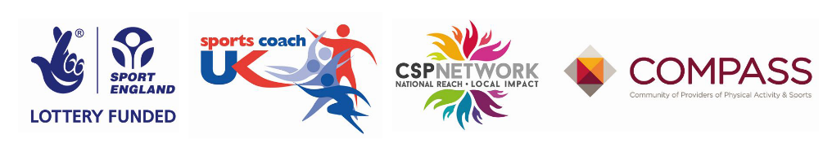
Review Date: 30/09/2017

